Team memebres

Alekhya Lingala

Aswani putta

Sai Shivani Boddireddy

Question 1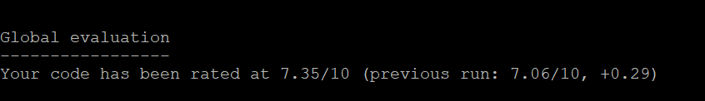

Question 2

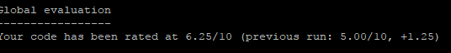

Question 3

